Press Announcement

Successful Research Project: the EDAG Group Pipeline "AIdentify"
Artificial intelligence redefines the evaluation and writing of short technical texts in automotive development
Lindau, 01/26/2023 After two years' research, the EDAG Group has completed the project "artificial intelligence for the semantic analysis of short technical texts", or "AIdentify". The focus of the project is on automated text analysis and editing using artificial intelligence, because it is complex, technical texts which form the basis of automotive development. Natural Language Processing, or NLP, is at the heart of such analyses. The project was carried out by the largest independent developer of mobility technology in cooperation with denkbares GmbH, a digital transformation think tank. Funded by the Bavarian State Ministry for Economic Affairs, Regional Development and Energy within the framework of the Bavarian Joint Research Program (BayVFP), the interdisciplinary team investigated the use of AI in the evaluation and application of short technical texts. The aim is to be able to detect inconsistencies in vehicle development, trends in the automotive industry and country-specific defects in vehicles more quickly and easily with the aid of NLP text analysis.
"For the EDAG Group, machine text analysis and generation is another milestone in the establishment and expansion of a future-oriented ecosystem for the mobility of tomorrow," says Cosimo De Carlo, director and CEO of the EDAG Group. "With the EDAG Pipeline AIdentify, we now have a promising prototype for the structured and largely automated transfer of knowledge and information that will significantly advance technology development in the automotive industry."

In the research project, EDAG's software development team led by Jacek Burger, Head of Embedded Systems & Computer Vision/AI, looked into whether, and if so how, NLP in particular can help us to deal with the rapid increase in the number of short texts. Especially in the automotive industry, large numbers of such short texts are generated in test bench reports or activity reports written by service technicians, for instance, or in customer complaints. These need to be automatically evaluated and processed in a database-based ticket system with the aid of AI.

"The difference between short technical texts and prose is that the former are written by numerous authors, all with different background knowledge. They often contain spelling mistakes, codes, abbreviations, multilingual terms and colloquialisms. This is where standard NLP concepts come up against their limits," says Nathalie Klingler, one of the EDAG Group's software engineers and a specialist in the field of explainable artificial intelligence, who, along with Jochen Nüßle, an EDAG Group software engineer in Lindau, was responsible for supervising the AIdentify project.

To the best of EDAG's AI team's knowledge, databases of this type have so far only been used for filing, and not as a source of knowledge. But this is about to change. "AIdentify permits the output of semantically similar texts based on an initial text. The AI evaluates the concepts, then derives from this recommendations for handling short technical texts. This enables employees to access solutions to similar problems, providing them with useful support in their work with short technical texts," says Jochen Nüßle.

The Pipeline AIdentify developed by the EDAG Group has reached a good, functional level now that the two-year research project has been completed. Already, it makes the extraction of similar texts from a database and their semantic processing possible.

"The pipeline already handles several applications in a way that is both useful and reliable," explains Jacek Burger. "It improves text quality, consistency checks in tickets, knowledge extraction, and also clustering.“ The aim now is to carry out additional evaluations and practical tests on the software, so as to develop a robust and modular toolbox which is ready for the market. It should be possible use it for additional applications and databases without too many adjustments.

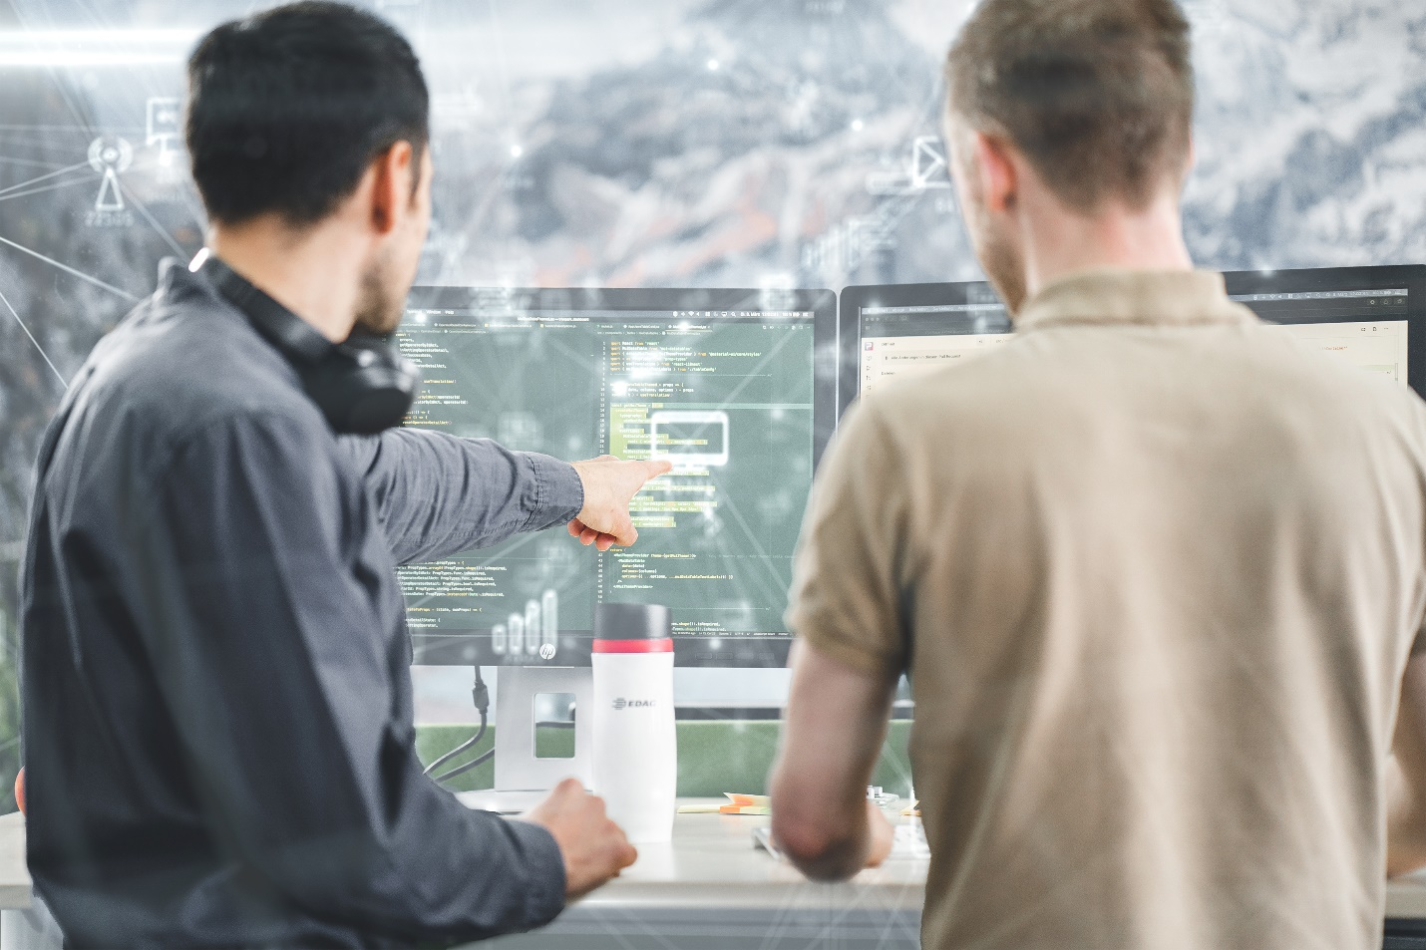
Caption:
EDAG Group develops Pipeline AIdentify for the extraction of similar texts from a database. Photo: EDAG Group

About EDAG
EDAG is the world's largest independent engineering service provider to the global mobility industry.
We regard mobility as a fully integrated ecosystem, and offer our customers technological solutions for more sustainable, emission-free and intelligently networked mobility.
With a global network of some 60 branches, EDAG provides engineering services in the Vehicle Engineering, Electrics/Electronics and Production Solutions segments.
With our interdisciplinary expertise in the fields of software and digitalization, we possess the key skills to help actively shape the dynamic transformation process the mobility industry is currently undergoing. Digital features, autonomous driving, artificial intelligence, alternative powertrains, new mobility concepts and the vision of a networked smart city have become an integral part of our portfolio. Embedded in EDAG's own 360° degree approach to the development of complete vehicles and production facilities, we are a competent partner for sustainable mobility projects. It is in the DNA of the company to actively shape the future of mobility and transfer new technologies and concepts into series production. Today, EDAG is one of the TOP 20 IT service providers in the German mobility sector.
Our customers include leading international OEMs, tier 1 suppliers and startup companies from the automotive and non-automotive industries, all of whom we serve globally with our workforce of approximately 8,000 experts in 360-degree engineering.
In 2021, the company generated sales of € 687 million. On December 31, 2021, EDAG employed a global workforce of 7,880 (including apprentices).

Do you have any questions, or need further information?
I look forward to hearing from you:
Felix Schuster Head Office
Head of Marketing & Communications EDAG Engineering GmbH
Cell phone: +49 173 7345473 Kreuzberger Ring 40
Email: felix.schuster@edag.com 65205 Wiesbaden
www.edag.com

