Press Announcement

EDAG Engineering GmbH again receives a Top Employer Award
Company demonstrates strong performance in the categories "People Strategy", "Employer Branding" and "Onboarding".

Fulda, 1/19/2023 - EDAG Engineering GmbH has once again received an award for its outstanding HR management. The independent jury of the Top Employers Institute testified to the outstanding working conditions offered by the world's largest independent engineering service provider in the mobility industry and technology developer for industrial solutions, and recognized its high level of employee orientation.
Cosimo De Carlo, director and CEO of the EDAG Group, is delighted at this latest award: "In our company, it is the people that matter most. The keen problem-solving skills and the high motivation of our employees are our added value on the market, and this certification shows that we can hold our own in a challenging and competitive environment with high demands."
The independent institute puts companies through an extensive validation process, taking numerous strategic and operative matters into account. Corporate strategy, HR development, sustainability, diversity, gender equality: this is just a small sample of the various fields that were subjected to the close scrutiny of the auditors during the certification process. The focus of validation is on internal processes - including talent strategy, apprenticeships, training, development and onboarding.
Throughout, EDAG Engineering GmbH was compared with numerous other companies from the same industrial sector. Worldwide, a large number of well-known companies took part in this year's Top Employer competition – including 150 in the category „Automobile“. The results achieved are evaluated according to an international standard.
"This award shows that we offer an outstanding working and development environment, while at the same time giving us the opportunity to uncover further potential," says Wolfgang Fries, Head of Global Recruiting & HR Business Partner. "The renewed certification is no reason for us to sit back and do nothing: it substantiates our commitment to constant improvement, so that we can successfully take on the challenges of the changing world of work and ensure our employees a superlative environment not just now, but also in the future."
Holger Merz, CFO of the EDAG Group, underlines this idea: "We are constantly investing in HR development and in new working environments. These subjects are extremely important to us, to ensure that we maintain a consistently high level of attractiveness as an employer. We offer an environment of encouragement and development for potential applicants, but also especially for our employees."
As an engineering partner for complete vehicles and production plants, the EDAG Group offers its employees a wealth of prospects for their professional and personal development. Numerous innovative projects at national and international locations make the EDAG Group one of the most attractive employers in the mobility sector for both career starters and people with experience.

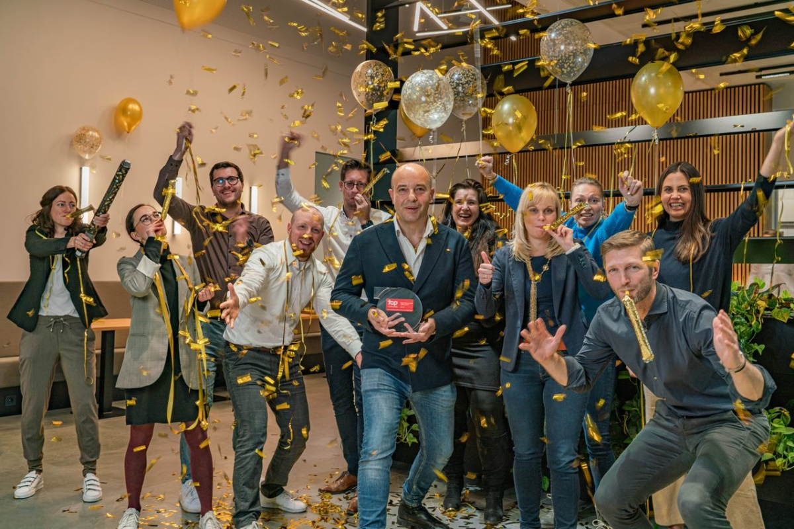Caption: EDAG Engineering GmbH's team celebrate the Top Employer award with EDAG Group CEO Cosimo De Carlo (center) und Wolfgang Fries, Head of Global Recruiting & HR Business Partner (front right).

Caption: EDAG Engineering GmbH's team celebrate the Top Employer award with EDAG Group CFO Holger Merz (center).

About EDAG
EDAG is the world's largest independent engineering service provider to the global mobility industry. We regard mobility as a fully integrated ecosystem, and offer our customers technological solutions for more sustainable, emission-free and intelligently networked mobility.
With a global network of some 60 branches, EDAG provides engineering services in the Vehicle Engineering, Electrics/Electronics and Production Solutions segments.
With our interdisciplinary expertise in the fields of software and digitalization, we possess the key skills to help actively shape the dynamic transformation process the mobility industry is currently undergoing. Digital features, autonomous driving, artificial intelligence, alternative powertrains, new mobility concepts and the vision of a networked smart city have become an integral part of our portfolio. Embedded in EDAG's own 360° degree approach to the development of complete vehicles and production facilities, we are a competent partner for sustainable mobility projects. It is in the DNA of the company to actively shape the future of mobility and transfer new technologies and concepts into series production. Today, EDAG is one of the TOP 20 IT service providers in the German mobility sector.
Our customers include leading international OEMs, tier 1 suppliers and startup companies from the automotive and non-automotive industries, all of whom we serve globally with our workforce of approximately 8,000 experts in 360-degree engineering.
In 2021, the company generated sales of € 687 million. On December 31, 2021, EDAG employed a global workforce of 7,880 (including apprentices).

Do you have any questions, or need further information?
I look forward to hearing from you:
Felix Schuster Head Office
Head of Marketing & Communications EDAG Engineering GmbH
Cell phone: +49 173 7345473 Kreuzberger Ring 40
Email: felix.schuster@edag.com 65205 Wiesbaden
www.edag.com

