Press Announcement

Inductive Charging not just for eCars
LaneCharge research project completed successfully - EDAG Group identifies further areas of application

December 07, 2023 - Within the context of a four-year research project, the EDAG Group, engineering service provider to the mobility industry and technology developer for industrial solutions, has developed and applied for a patent on a process for the inductive charging of electric cars. Under the project name "LaneCharge", the Group joined forces with partners from science and industry to develop a new technology that will revolutionize the provision of a low-cost, robust and interoperable charging infrastructure.
As a result of the EDAG innovation, it will be possible for eCars to be charged without human intervention in the future: when parked, waiting at traffic lights, at home in the garage – wirelessly, at recurring short intervals, and using the same technology in both the public and the private sphere. Dr.-Ing. Jan Leilich, Head of Innovations at the EDAG Group, underlines the advantages of the process: "Unlike previous attempts to find solutions, the charging intelligence is no longer in the road, but in the vehicle. This means the technology embedded in the road is simpler and robuster than it was in the past." The EDAG Group has applied for a patent on this new process.
The project results were presented to the public for the first time at the official closing event on the grounds of Hanover University of Applied Sciences and Arts. Up to 12 induction coils can be charged wirelessly over a test distance of more than 90 meters here.
"We are very happy to have been able to present the technology to a broad audience together with the entire project team," emphasizes Matthias Girlach, Head of the Embedded Systems department at the EDAG Group. "Inductive charging is not just an issue for electric vehicles - we also see great potential for the use of this technology in intralogistics, for instance. The advantages are obvious: for one, of course, the convenience. But even more important is the potential for automation. Inductive charging is becoming an increasingly important factor for automated vehicles, both in private and in non-public areas such as industrial parks or on airport aprons. We have already established contact with our first new customers in the industrial electronics sector."
In addition to the EDAG Group, the project team consisted of the Hanover University of Applied Sciences and Arts, the Technische Universität Braunschweig and SUMIDA Components & Modules.
The "LaneCharge" research project has been funded to the tune of € 2.77 million within the scope of the Electromobility Funding Directive of the Federal Ministry of Transport and Digital Infrastructure (BMDV). The directive was coordinated by NOW GmbH, and implemented by project sponsor Jülich (PtJ).

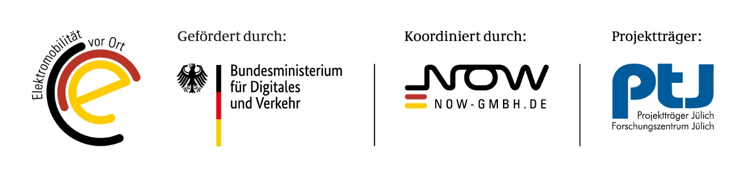
Photos: Opening of the university test site for inductive charging in Hanover

About the EDAG Group
EDAG Group is a globally leading, independent engineering service provider that combines excellent engineering with the latest technology trends.
With a global network of some 60 branches, the EDAG Group implements projects in the Vehicle Engineering, Electrics/Electronics and Production Solutions segments. Drawing on more than 50 years of engineering experience, EDAG's proprietary 360-degree development approach has become a hallmark of quality in the holistic development of vehicles and smart factories. The company's interdisciplinary expertise in the areas of software and digitization provides it with crucial skills to actively shape dynamic transformation processes as an innovative partner.
With an interdisciplinary team of around 8,600 experts, the EDAG Group develops unique mobility and industrial solutions for customers that include the world's leading automotive and non-automotive companies. The company is listed on the stock exchange since 2015 and generated sales of € 796 million in 2022.
For more information, see the EDAG Group website: www.edag.com
Do you have any questions, or need further information?
I look forward to hearing from you:
Felix Schuster Head Office
Head of Marketing & Communications EDAG Engineering GmbH
Cell phone: +49 173 7345473 Kreuzberger Ring 40
Email: felix.schuster@edag.com 65205 Wiesbaden
www.edag.com

