Press Announcement

Zero Prototype Lab: EDAG Group opens simulator center
Driving and testing vehicles virtually before building them.

Wolfsburg, 11/21/2023 - The EDAG Group is venturing into new dimensions of vehicle development in Wolfsburg: in the new EDAG Zero Prototype Lab, the Group's first vehicle dynamics simulation center, vehicles, their functions and their driving dynamics are comprehensively tested in realistic driving situations before the physical vehicle is created. A groundbreaking, innovative simulation technology makes this possible.
The center for driving dynamics simulation is unique in Europe and will start operations in Wolfsburg in May 2024. It will have three test platforms for research and development in the areas of hardware, software and human machine interface (HMI).
Driving a new vehicle virtually and testing its functions before it is physically built will not only reduce cost-intensive prototypes but also shorten development cycles. The new EDAG Engineering GmbH vehicle dynamics simulation center in Wolfsburg will allow this type of vehicle development in the future. "The transformation of the automotive industry is progressing. In order to support technology developers and OEMs on their way to faster, more sustainable and more precise development, we have revolutionized the product development process," says Harald Keller, COO of EDAG Engineering GmbH. "The EDAG Zero Prototype Lab is the first vehicle dynamics simulation center of its kind - and it is open to all market participants. We are thus opening a whole new chapter in automotive technology development for our customers."
For this chapter, the EDAG Group relies on state of the art technology. The Zero Prototype Lab is home to the Dynamic Simulator DiM500 from the company VI-grade, which is the largest and most powerful cable-driven simulator for development, racing and research focusing on vehicle dynamics, vehicle movement and driver interaction. The DiM500 driving simulator enables to reproduce vehicle dynamics maneuvers involving large planar displacements with no motion cueing, which allows drivers to immerse themselves in a virtual environment and experience realistic driving.

"This includes even complex driving maneuvers, such as a double lane change. Forces and momentum from a wide variety of driving situations are transmitted to the cockpit in real time," emphasizes Guido Bairati, Managing Director at VI-grade. All scenarios tested with the virtual prototypes are documented in the connected data center and thus made available for data analysis and the next development steps.
"This eliminates the need for time-consuming and costly testing of prototypes in the early development phases of the product creation process. Complex test tracks and the associated risks, such as failure or delays due to unpredictable environmental and weather conditions, are now a thing of the past," says Jonas Grötzinger, Senior Expert Vehicle Motion. “As a result, the 'time to market' will be significantly reduced." The EDAG Zero Prototype Lab will be open to all market participants starting in May 2024.
You can find further information on the EDAG Zero Prototype Lab here: EDAG Zero Prototype Lab | EDAG Group
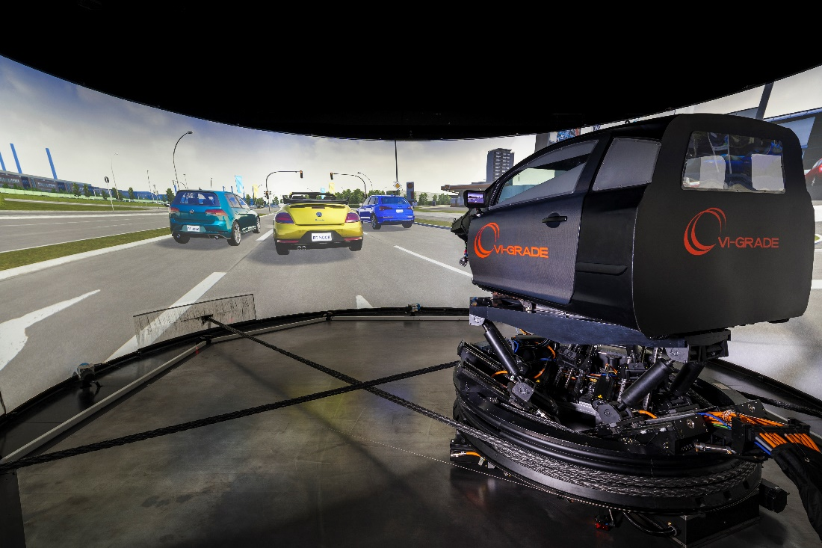
Picture 1: The EDAG Group's first vehicle dynamics simulation center allows for vehicles, their functions, and their driving dynamics comprehensive testing in realistic driving situations before the physical vehicle is created | Photo: VI-grade

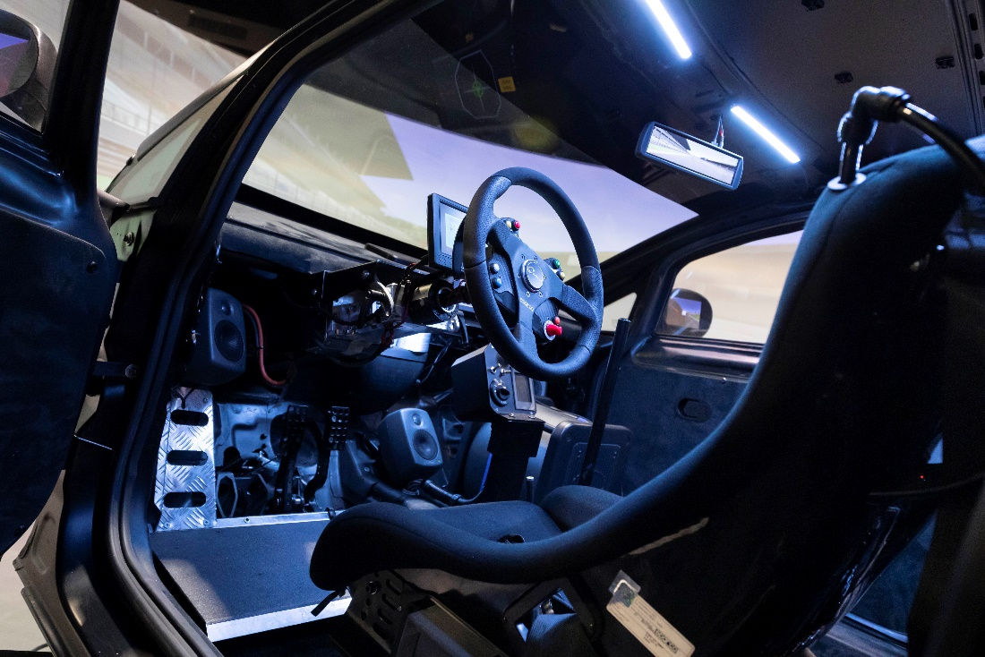
Picture 2: Eliminates the need for time-consuming and costly testing of prototypes in the early development phases: EDAG Zero Prototype Lab | Photo: VI-grade

About the EDAG Group
EDAG Group is a globally leading, independent engineering service provider that combines excellent engineering with the latest technology trends.
With a global network of some 60 branches, the EDAG Group realizes projects in the Vehicle Engineering, Electrics/Electronics and Production Solutions segments. Drawing on more than 50 years of engineering experience, EDAG's proprietary 360-degree development approach has become a hallmark of quality in the holistic development of vehicles and smart factories. The company's interdisciplinary expertise in the areas of software and digitization provides it with crucial skills to actively shape dynamic transformation processes as an innovative partner.
With an interdisciplinary team of around 8,600 experts, the EDAG Group develops unique mobility and industrial solutions for customers that include the world's leading automotive and non-automotive companies. The company is listed on the stock exchange since 2015 and generated revenues of € 796 million in 2022.
For more information, see the EDAG Group website: www.edag.com
Do you have any questions, or need further information?
I look forward to hearing from you:
Felix Schuster Head Office
Head of Marketing & Communications EDAG Engineering GmbH
Cell phone: +49 173 7345473 Kreuzberger Ring 40
Email: felix.schuster@edag.com 65205 Wiesbaden
www.edag.com

About VI-grade

VI-grade is the global provider of disruptive vehicle development solutions that are paving the way to developing vehicles with Zero Prototypes.

Its human-centric solutions comprise industry-leading real-time simulation software, professional driving simulators and Hardware-in-the-Loop solutions that accelerate product development across the transportation industry.

The company’s suite of scalable driving simulators covers a wide performance range to assess the multi-disciplinary driving experience. These proven solutions enable OEMs, suppliers, research centers, motorsport teams and universities to reduce physical prototypes while accelerating innovation in their quest to get ever nearer to achieving the ultimate development goal of Zero Prototypes.
VI-grade is part of HBK’s Virtual Test Division, which focuses on providing real-time software, simulator, and hardware-in-the-loop solutions to virtually test products throughout the development cycle, helping companies accelerate innovation and reduce time-to-market, and improve their competitive advantage.

For further information, please visit https://www.VI-grade.com

The VI-grade logo and all VI-grade product names are trademarks or registered trademarks of VI-grade GmbH

Contact VI-grade:
Gabriele Ferrarotti - Marketing Director
VI-grade Srl ▪ Corso Ferrucci 112 ▪ 10141 Torino ▪ Italy
Phone: +39 349 5458021
E-mail: gabriele.ferrarotti@VI-grade.com

