Press Announcement

JEC World Paris:
EDAG Group, Mitsubishi Chemical and Kreisel Electric present innovative lightweight battery housing

Wiesbaden / Paris, April 18.2023 - The transition to electric vehicles has set high safety requirements for battery technology, and this also includes the housing that protects the batteries. Conventional battery housings are frequently made of heavy metallic profiles and molded parts, which can, however, have a negative effect on overall weight and vehicle performance. Interest in lightweight battery housings made of functional composite materials which offer both high safety levels and durability is therefore growing. EDAG - engineering service provider to the mobility industry and technology developer for industrial solutions - and material suppliers Mitsubishi Chemical Group have joined forces with the battery system manufacturer Kreisel Electric to design a new concept.
The result is an extremely lightweight battery concept capable of meeting all the requirements for a battery housing for electric vehicles. Dr. Stefan Caba, Head of the Innovations Field Safe Mobility at the EDAG Group, describes the vehicle categories for which the innovative lightweight battery housing is suitable: "With our lightweight but powerful battery storage, we are in particular addressing customers who produce medium quantities. From high-performance vehicles such as electrified sport cars to people movers – the weight reduction coupled with the possibility of manufacturing the battery box in a single process create a great competitive edge in the market."
The concept is to be presented to the international public for the first time ever at the JEC World Expo (April 25 – 27) in Paris, the world's leading trade fair for composite materials (stand H60 in hall 6).
Functional composite materials made by the Mitsubishi Chemical Group are used to achieve the required range of properties. Using these materials in battery housings enables lightweight structures to be created that provide the strength and stiffness necessary to meet crash requirements for automobile applications. Fire protection and electromagnetic shielding are also taken care of. To this end, use is made of MAFTECTM, a material predestined for insulation, which, with the help of ceramic fibers, creates a fireproof barrier. A forged molding compound (FMC) was selected for the complex areas. "When we were developing the high-voltage storage system, care was also taken to ensure that all components can be returned to the material cycle; recycling fiber-reinforced plastics and reusing the raw materials recovered for new semi-finished products is one of the cornerstones of our global growth strategy," explains John Conn, Engineering Project Manager Advanced Materials.
Special mention should be made of the cell technology provided by Kreisel Electric. The cells here are tempered in a patented KREISEL hollow block, by means of immersion cooling, in which a dielectric fluid comes into direct contact with the cells. This is an extremely effective means of heat dissipation and of guaranteeing an exceptionally small temperature spread. At the same time, cell technology which is particularly suitable for high-performance applications is also available.
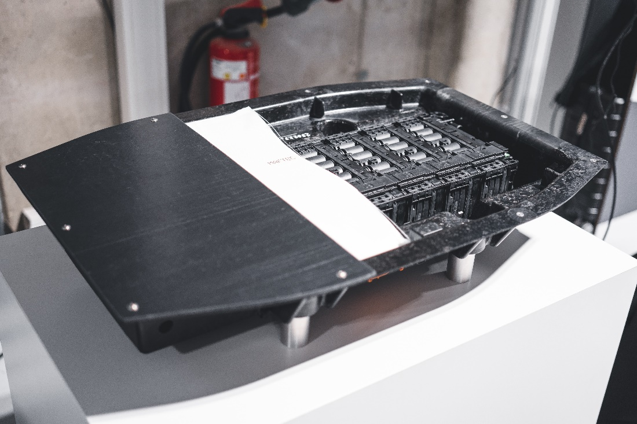

Innovative lightweight battery housing (photo: EDAG Group)

About EDAG
EDAG is the world's largest independent engineering service provider to the global mobility industry.
We regard mobility as a fully integrated ecosystem, and offer our customers technological solutions for more sustainable, emission-free and intelligently networked mobility.
With a global network of some 60 branches, EDAG provides engineering services in the Vehicle Engineering, Electrics/Electronics and Production Solutions segments.
With our interdisciplinary expertise in the fields of software and digitalization, we possess the key skills to help actively shape the dynamic transformation process the mobility industry is currently undergoing. Digital features, autonomous driving, artificial intelligence, alternative powertrains, new mobility concepts and the vision of a networked smart city have become an integral part of our portfolio. Embedded in EDAG's own 360 degree approach to the development of complete vehicles and production facilities, we are a competent partner for sustainable mobility projects. It is in the DNA of the company to actively shape the future of mobility and transfer new technologies and concepts into series production. Today, EDAG is one of the TOP 20 IT service providers in the German mobility sector.
Our customers include leading international OEMs, tier 1 suppliers and startup companies from the automotive and non-automotive industries, all of whom we serve globally with our workforce of approximately 8,400 experts in 360-degree engineering.
In 2022, the company generated sales of € 796 million. On December 31, 2022, EDAG employed a global workforce of 8,412 (including apprentices).

Do you have any questions, or need further information?
I look forward to hearing from you:
Felix Schuster Head Office
Head of Marketing & Communications EDAG Engineering GmbH
Cell phone: +49 173 7345473 Kreuzberger Ring 40
Email: felix.schuster@edag.com 65205 Wiesbaden
www.edag.com

