Press Announcement

DTM 2023:
EDAG Group and SSR Performance in the line-up with Lamborghini
Longstanding vehicle development expertise meets professional driving skills: Partnership between EDAG Group and SSR Performance GmbH enters the next phase.
Munich, April 11, 2023 The EDAG Group is to support the SSR Team as its technical partner during the DTM – for the second time in a row. The racing team consists of Mirko Bortolotti, Franck Perera and Alessio Deledda. The first race will take place in Oschersleben, Saxony-Anhalt, on May 25 - 28. The team will be starting the season with three new Lamborghini Huracán GT3 EVO2s. After their successful debut last year and their victory in the race in Spa-Francorchamps, SSR will be starting their second year in the DTM this 2023 season.
"The kind of high-performance vehicles we see in motorsport have always been innovation drivers for series development – in terms of weight reduction, the use of new materials, hybridization or in the development and use of e-fuels. Future technologies are often first tested on the race track, especially with regard to vehicle attributes such as weight, power and aerodynamics," explains Harald Keller, COO of EDAG Engineering GmbH. "We are pleased to have found such a professional and dedicated team as SSR Performance for a technical partnership."
The EDAG Group has long-standing international development expertise in the mobility sector, and, as a premium engineering partner, serves many well-known vehicle manufacturers and Tier 1 suppliers worldwide. Founded in 1969, the company pursues an all-round engineering approach for vehicles, production plants, and also in the field of software and digitalization. Always with the ultimate goal of proactively developing concepts and solutions for the mobility of the future. In the high performance sector, too, the EDAG Group can look back on years of experience.
Stefan Schlund, Managing Director of SSR Performance GmbH, is certain: With the continuation of the technical partnership with the EDAG Group, the 2023 DTM season will once again be a joint success: "With the EDAG Group, we have for more than two years had a reliable and competent partner at our side. We are really looking forward to further developing this strong cooperation."
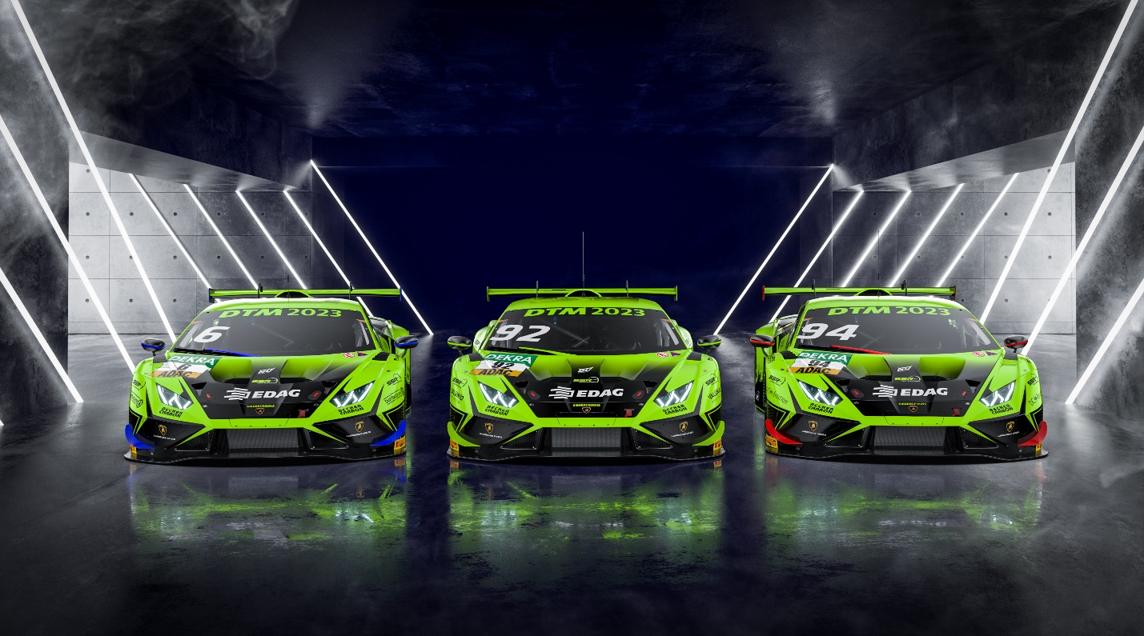EDAG Group and SSR Performance continue their technical partnership. (Photo: SSR Performance GmbH)

About EDAG
EDAG is the world's largest independent engineering service provider to the global mobility industry.
We regard mobility as a fully integrated ecosystem, and offer our customers technological solutions for more sustainable, emission-free and intelligently networked mobility.
With a global network of some 60 branches, EDAG provides engineering services in the Vehicle Engineering, Electrics/Electronics and Production Solutions segments.
With our interdisciplinary expertise in the fields of software and digitalization, we possess the key skills to help actively shape the dynamic transformation process the mobility industry is currently undergoing. Digital features, autonomous driving, artificial intelligence, alternative powertrains, new mobility concepts and the vision of a networked smart city have become an integral part of our portfolio. Embedded in EDAG's own 360° degree approach to the development of complete vehicles and production facilities, we are a competent partner for sustainable mobility projects. It is in the DNA of the company to actively shape the future of mobility and transfer new technologies and concepts into series production. Today, EDAG is one of the TOP 20 IT service providers in the German mobility sector.
Our customers include leading international OEMs, tier 1 suppliers and startup companies from the automotive and non-automotive industries, all of whom we serve globally with our workforce of approximately 8,400 experts in 360-degree engineering.
In 2022, the company generated sales of € 796 million. On December 31, 2022, EDAG employed a global workforce of 8,412 (including apprentices).

Do you have any questions, or need further information?
I look forward to hearing from you:
Felix Schuster Head Office
Head of Marketing & Communications EDAG Engineering GmbH
Cell phone: +49 173 7345473 Kreuzberger Ring 40
Email: felix.schuster@edag.com 65205 Wiesbaden
www.edag.com

