Press Announcement

EDAG Group Opens Extended Facility in Ingolstadt
Almost 1,000 employees work at the new EDAG Campus

Ingolstadt, March 16, 2023 – The EDAG Group, the world's largest independent engineering service provider in the mobility industry and technology developer for industrial solutions, has enlarged its premises at the Ingolstadt Robert-Bosch-Straße site to create an integrated engineering center. In addition to offering a comprehensive range of services in vehicle and production plant development, Ingolstadt has as a result become one of the largest software and digitalization hubs within the EDAG Group. This is the company's response to the steadily growing demand for digital services for the mobility industry. The Campus has office, testing and storage space covering an area of more than 18,500 m². With this step, the company is merging several of its sites in Ingolstadt and Gaimersheim, providing workplaces for 950 employees.

The company has had premises in the Ingolstadt region since 1977, and has continuously expanded its competencies and capacities over the last few decades. The new building which has now been completed in the Robert-Bosch-Straße underlines our long-term ties with the region and the importance of the location. The new facility features over 600 workplaces for 950 employees, 16 meeting rooms, as well as testing and storage space. The Campus is equipped with electric charging stations, and has energy-efficient water source heat pumps for the heating and air conditioning systems. Construction took two years, the ground-breaking ceremony was in summer 2020.

"From a workforce of 10 to 950 – we are proud of Ingolstadt's more than 40-year history of constant growth," says Frank Schmidt, Manager of the Ingolstadt site. "The new site is a unique hub for future-oriented services centering on software and digitalization." Around the globe, the EDAG Group has more than 8,400 employees working on innovative projects and new concepts. The employees are of special importance in the EDAG Group, a fact which is demonstrated by the Top Employer award, an independent certification the company has recently received again.

"With its actively implemented new work concepts and modern work bar, the new Campus shows just how important HR development and new working worlds are to us," says Cosimo De Carlo, CEO of the EDAG Group. "With our Campus in Ingolstadt, we have created optimal conditions that will enable our 950 EDAG colleagues to create innovations with our customers."

"Ingolstadt is an ideal and promising location for high-performance companies. With the EDAG Group's new Campus, Ingolstadt has gained another highly attractive location for young talents and professionals in the field of the mobility of the future," says Prof. Dr. Georg Rosenfeld, Business Advisor of the City of Ingolstadt.

The EDAG Group is bundling its extensive expertise and experience in the integrated development of products, production and digital solutions for the automotive industry, commercial vehicles, motorcycles and the aerospace industry in Ingolstadt.

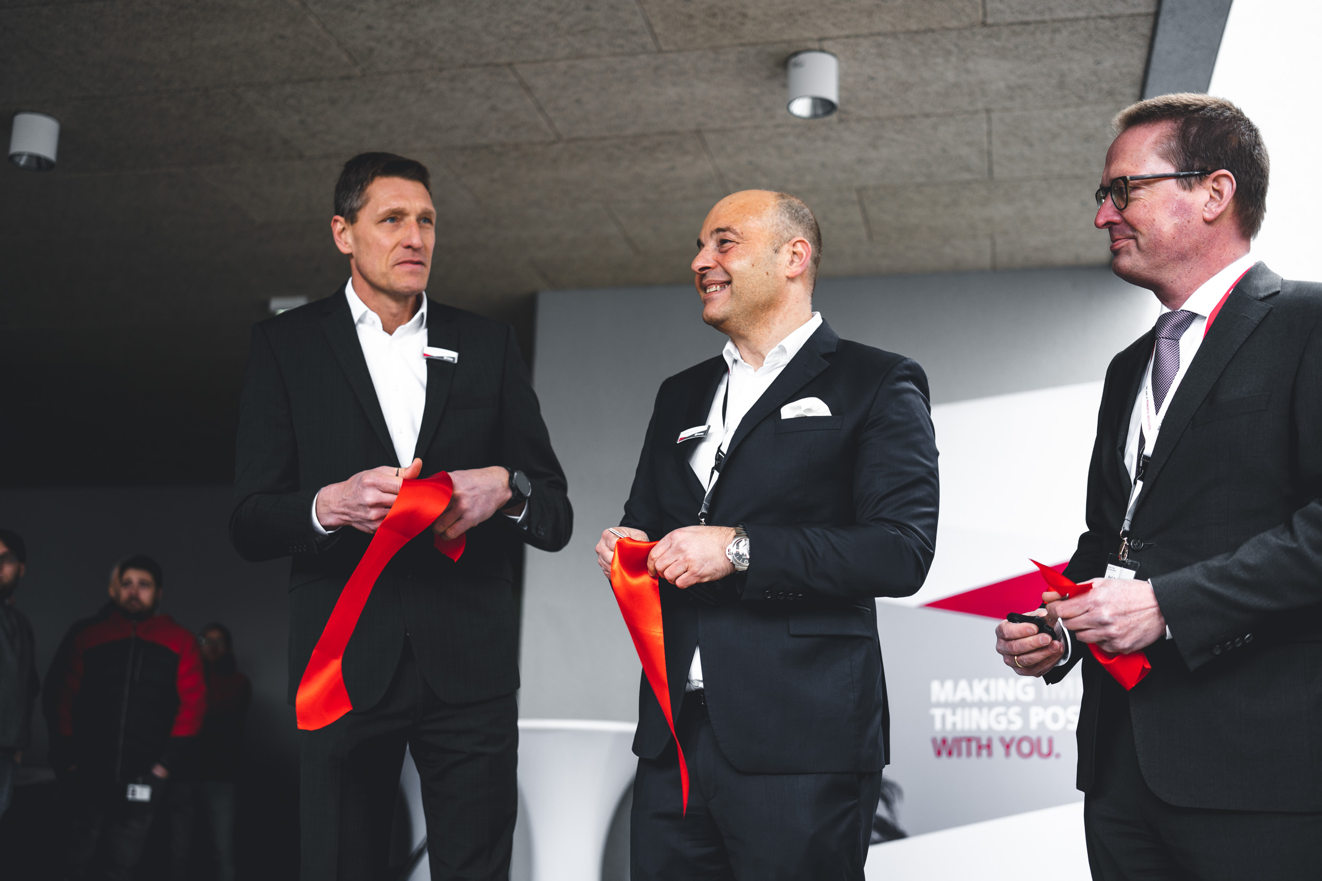At the official opening of the new EDAG Campus Ingolstadt (from left to right): Frank Schmidt (Branch Manager of EDAG Ingolstadt), Cosimo De Carlo (CEO of the EDAG Group), Prof. Dr. Georg Rosenfeld (Business Advisor of the City of Ingolstadt)

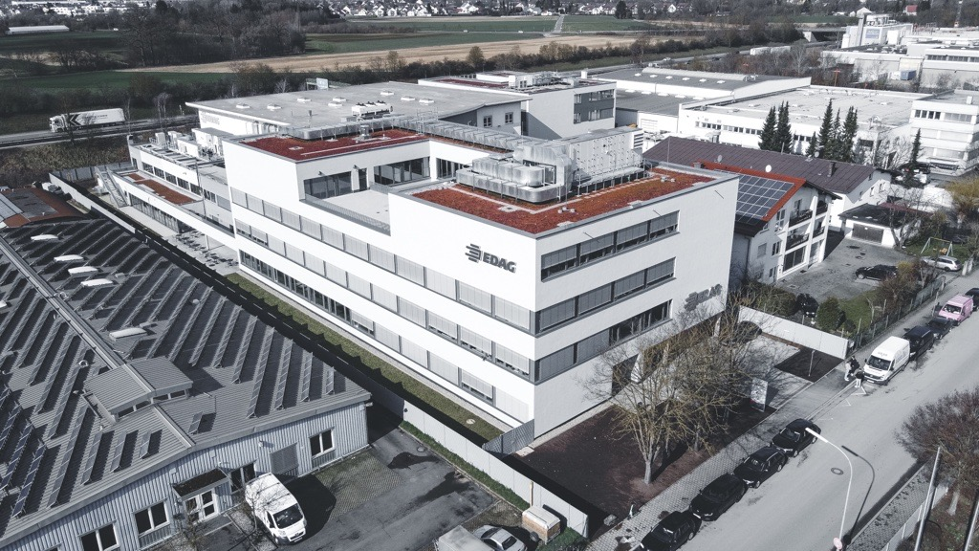EDAG is merging several of its sites in Ingolstadt and Gaimersheim at the new Campus Ingolstadt, providing workplaces for 950 employees.

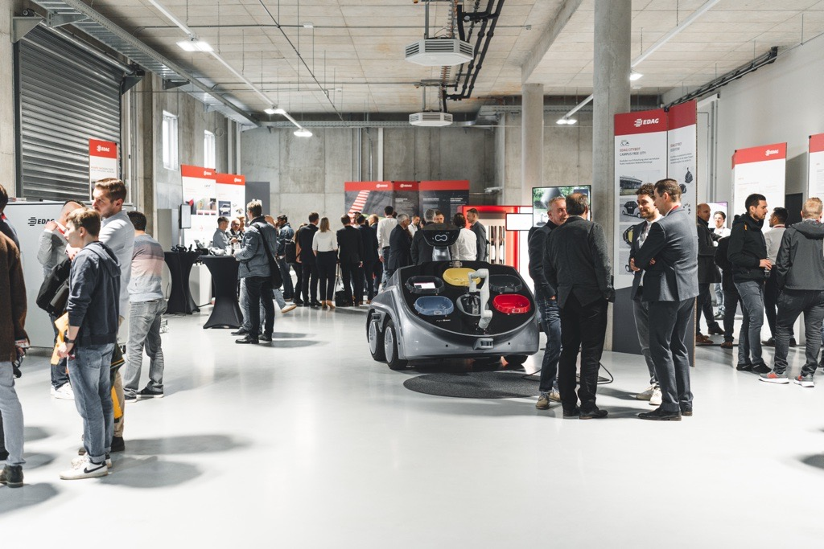At a well-attended exhibition held during the opening celebrations, the EDAG Group presented innovative projects and its product range to its guests.

About EDAG
EDAG is the world's largest independent engineering service provider to the global mobility industry.
We regard mobility as a fully integrated ecosystem, and offer our customers technological solutions for more sustainable, emission-free and intelligently networked mobility.
With a global network of some 60 branches, EDAG provides engineering services in the Vehicle Engineering, Electrics/Electronics and Production Solutions segments.
With our interdisciplinary expertise in the fields of software and digitalization, we possess the key skills to help actively shape the dynamic transformation process the mobility industry is currently undergoing. Digital features, autonomous driving, artificial intelligence, alternative powertrains, new mobility concepts and the vision of a networked smart city have become an integral part of our portfolio. Embedded in EDAG's own 360° degree approach to the development of complete vehicles and production facilities, we are a competent partner for sustainable mobility projects. It is in the DNA of the company to actively shape the future of mobility and transfer new technologies and concepts into series production. Today, EDAG is one of the TOP 20 IT service providers in the German mobility sector.
Our customers include leading international OEMs, tier 1 suppliers and startup companies from the automotive and non-automotive industries, all of whom we serve globally with our workforce of approximately 8,000 experts in 360-degree engineering.
In 2021, the company generated sales of € 687 million. On December 31, 2021, EDAG employed a global workforce of 7,880 (including apprentices).

Do you have any questions, or need further information?
I look forward to hearing from you:
Felix Schuster Head Office
Head of Marketing & Communications EDAG Engineering GmbH
Cell phone: +49 173 7345473 Kreuzberger Ring 40
Email: felix.schuster@edag.com 65205 Wiesbaden
www.edag.com

