Press Announcement

EDAG Group's new Functional Safety Certificate Course
New Partnership Formed with the Chamber of Industry and Commerce (IHK)

August 18, 2022 The EDAG Group, the world's largest independent engineering service provider for fully integrated solutions in the mobility industry, is now offering a functional safety certificate course, available in various versions, at the Chamber of Commerce (IHK).
Having successfully implemented its staff qualification internally for several years, the EDAG Group will from now on also be legitimizing its competence with an official and independent partner. As an official provider of Chamber of Commerce courses in functional safety, the EDAG Group was first put through an IHK test procedure, during which concept, teaching units and contents were verified. In terms of both type and scope, the resulting training program is currently unique on the market. Candidates are examined by the Chamber of Commerce, as an independent body. Certificates are awarded to those who pass, officially qualifying them to perform professions in a safety-related context.

Three different versions of the functional safety staff qualification are available:
- Basic: Participants are taught the basic theory of all areas of functional safety in two to three months. The program consists of two elements: a short joint training phase in which basic skills are imparted, and a self-study period held in cooperation with qualified mentors from the EDAG Group.
- Advanced: Extension of the Basic level, with a duration of nine to 18 months. In addition to the contents of the Basic module, participants also do guided project work in the field of functional safety, independently creating work products in the process.
- Expert: 1.5 to 3-year module with the contents of the Basic und Advanced modules, plus independent project work. The aim is to intensify knowledge by doing practical work for different projects.

The course can be booked either via the IHK course portal or by contacting the EDAG Group direct. Both full-time and part-time models are possible. Qualified experts from the EDAG Group support the course participants in various activities: planning the training steps, organizing and setting up workshops, carrying out exercises and preparing reports for customers. Further, the EDAG Group's functional safety employees are willing to assist the examinees by answering the numerous safety-related questions they have in their daily work. The teaching units and concepts are individually adapted to the employee's role and the projects he or she is working on. In other words, the course participants are trained using real scenarios from the field of functional safety.

"We are very proud of the fact that we are now able to officially offer our dual courses through the Chamber of Commerce," says René Hermann, EDAG Group team leader and contact for functional safety. "In light of the growing awareness for functional safety, demand for the certificate is currently rising enormously. The comprehensive contents we offer, our highly qualified expertise and the individual concept of our course enable us to offer a hands-on program that qualifies participants for professions in the field of functional safety."

"We, the Chamber of Commerce, are pleased to be able to organize this course in cooperation with the EDAG Group," says Lisa Maibach of the IHK. "More and more companies are realizing how important the qualification is for functional safety. On completion of the course, participants now receive an IHK certificate that is acknowledged throughout the industry."
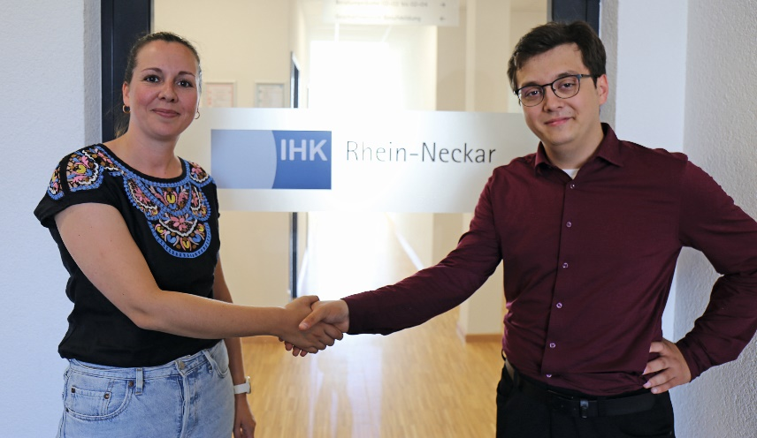
Caption: Lisa Maibach (Rhein-Neckar branch of the IHK) und René Hermann (EDAG Group functional safety team leader) have set up the certificate course. (Photo: EDAG Group)

About EDAG
EDAG is the world's largest independent engineering service provider to the global mobility industry.
We regard mobility as a fully integrated ecosystem, and offer our customers technological solutions for more sustainable, emission-free and intelligently networked mobility.
With a global network of some 60 branches, EDAG provides engineering services in the Vehicle Engineering, Electrics/Electronics and Production Solutions segments.
With our interdisciplinary expertise in the fields of software and digitalization, we possess the key skills to help actively shape the dynamic transformation process the mobility industry is currently undergoing. Digital features, autonomous driving, artificial intelligence, alternative powertrains, new mobility concepts and the vision of a networked smart city have become an integral part of our portfolio. Embedded in EDAG's own 360° degree approach to the development of complete vehicles and production facilities, we are a competent partner for sustainable mobility projects. It is in the DNA of the company to actively shape the future of mobility and transfer new technologies and concepts into series production. Today, EDAG is one of the TOP 20 IT service providers in the German mobility sector.
Our customers include leading international OEMs, tier 1 suppliers and startup companies from the automotive and non-automotive industries, all of whom we serve globally with our workforce of approximately 8,000 experts in 360-degree engineering.
In 2021, the company generated sales of € 687 million. On December 31, 2021, EDAG employed a global workforce of 7,880 (including apprentices).

Do you have any questions, or need further information?
I look forward to hearing from you:
Felix Schuster Head Office
Head of Marketing & Communications EDAG Engineering GmbH
Cell phone: +49 173 7345473 Kreuzberger Ring 40
Email: felix.schuster@edag.com 65205 Wiesbaden
www.edag.com

