Press Announcement

The Best of Hesse: EDAG Group and EintrachtTech Launch Partnership

Fulda/Frankfurt, 8/4/2022 - Both parties are among the best in their fields, both are geared to the future: the EDAG Group, the world's largest independent engineering service provider in the mobility industry, and EintrachtTech, the independent digital subsidiary of Eintracht Frankfurt, this year's European League winners, announce their partnership. The two partners are joining forces to focus on an all-round approach to digitalization. This can also be seen from the "Campus FreeCity real lab for the research of a networked fleet of modular robot vehicles" project, which has recently been jointly implemented and is funded by the Federal Ministry of Transport and Digital Infrastructure (BMDV).
"With the EDAG CityBot at the Campus FreeCity in the Deutsche Bank Park, the focus is not just on a revolutionary vehicle, but also on a complete ecosystem that the EDAG Group has developed for the mobility, transport and service tasks of a smart city," explains Holger Merz, CFO of the EDAG Group. EDAG CityBots are multi-functional, fully autonomous robot vehicles that move without emissions. Designed for a complete smart city ecosystem, this makes it the first and only mobility system to effectively counteract traffic gridlock. Thanks to their innovative and modular design, the EDAG CityBots can be used for a wide variety of different transport tasks - around the clock. EintrachtTech offers a unique digital center in the form of the "Arena of IoT" where this can be researched, and in which many different innovation partners and start-ups from Eintracht Frankfurt's network are brought together to create a "perfect playing field" on which the innovative strength of the partners involved can be made visible and tangible. "We are pleased that, through our work with EintrachtTech, the progress that has already been made with the research project will be advanced, and that we are now an official partner of the "Arena of IoT"," adds Holger Merz. Hesse will therefore become a real lab for the future of mobility - be this in Germany or internationally.

"The digitalization of all areas of life and work continues unabated. With this partnership, the EDAG Group and EintrachtTech want to make a sociopolitical contribution towards making our cities quieter, cleaner, more life enhancing and smarter in the future," explains EDAG Group CEO Cosimo De Carlo.
"Eintracht Frankfurt sees itself not just as a professional soccer club. Through EintrachtTech, it also takes an active role as a driver of the region in the field of digitalization," stresses Timm Jäger, CEO of EintrachtTech GmbH. The stadium is an ideal place to test "IoT" solutions in cooperation with technology partners like the EDAG Group, and to offer innovative projects a realistic test environment. With its digital center, Eintracht Frankfurt is actively strengthening the Frankfurt Rhine-Main digital location.
As Holger Merz sees it, there is "great potential" in this cooperation: "We experience EintrachtTech as an innovative and motivated technology pioneer, and are very much looking forward to this intensive and in many respects trendsetting partnership. This is the best of Hesse.
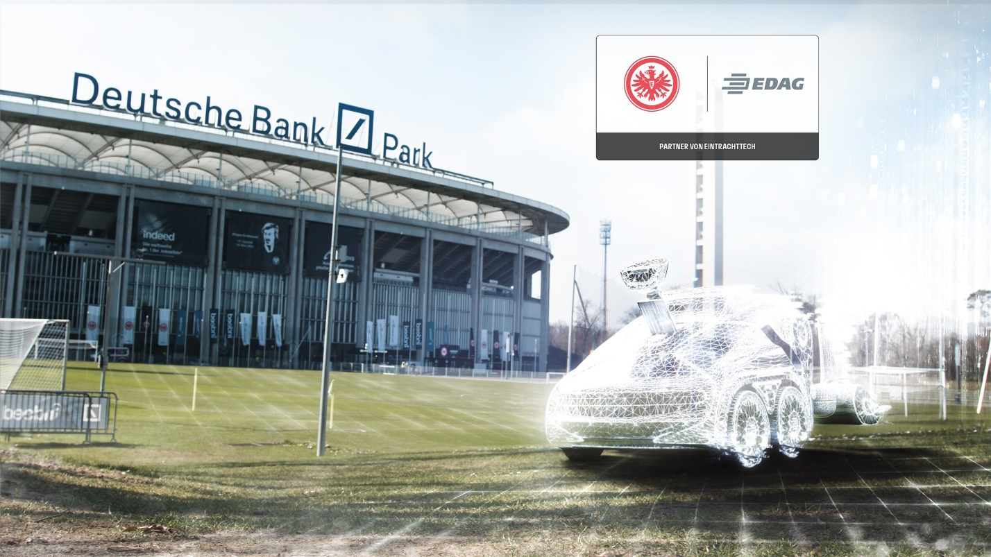Photo: EDAG Group and EintrachtTech announce their partnership

About EintrachtTech
With the founding of EintrachtTech GmbH, Eintracht Frankfurt has created its own digital subsidiary, which is responsible for all of Eintracht's strategic digital projects. In addition to developing the mainaqila app and Eintracht's central systems, EintrachtTech GmbH is responsible for setting up the digital center "Arena of IoT" in the Deutsche Bank Park and for the digitalization of the stadium. What is more, EintrachtTech is in charge of Eintracht's eSports activities and all technological cooperations at startup and university level.

About EDAG
EDAG is the world's largest independent engineering service provider to the global mobility industry.
We regard mobility as a fully integrated ecosystem, and offer our customers technological solutions for more sustainable, emission-free and intelligently networked mobility.
With a global network of some 60 branches, EDAG provides engineering services in the Vehicle Engineering, Electrics/Electronics and Production Solutions segments.
With our interdisciplinary expertise in the fields of software and digitalization, we possess the key skills to help actively shape the dynamic transformation process the mobility industry is currently undergoing. Digital features, autonomous driving, artificial intelligence, alternative powertrains, new mobility concepts and the vision of a networked smart city have become an integral part of our portfolio. Embedded in EDAG's own 360° degree approach to the development of complete vehicles and production facilities, we are a competent partner for sustainable mobility projects. It is in the DNA of the company to actively shape the future of mobility and transfer new technologies and concepts into series production. Today, EDAG is one of the TOP 20 IT service providers in the German mobility sector.
Our customers include leading international OEMs, tier 1 suppliers and startup companies from the automotive and non-automotive industries, all of whom we serve globally with our workforce of approximately 8,000 experts in 360-degree engineering.
In 2021, the company generated sales of € 687 million. On December 31, 2021, EDAG employed a global workforce of 7,880 (including apprentices).

Do you have any questions, or need further information?
I look forward to hearing from you:
Felix Schuster Head Office
Head of Marketing & Communications EDAG Engineering GmbH
Cell phone: +49 173 7345473 Kreuzberger Ring 40
Email: felix.schuster@edag.com 65205 Wiesbaden
www.edag.com

