Press Announcement

Complete vehicle engineering from a single source: EDAG and Bosch Engineering agree to project-based collaboration

Abstatt / Fulda, February 21, 2024 – EDAG Engineering GmbH and Bosch Engineering GmbH have signed a memorandum of understanding regarding project-based collaboration in complete vehicle engineering. With this agreement, the companies have declared their intention to offer their competencies jointly to the market in the future in order to complement each other’s expertise in the best way possible. This means that customers will receive seamless, complete vehicle engineering that is tailored to their needs from a single source without having to worry about coordinating the individual engineering areas.

What connects Bosch Engineering and EDAG is their comprehensive experience gained during the implementation of complete vehicle projects. “Ever stricter environmental and sustainability requirements and trends such as the software-defined vehicle lead to increasing complexity in vehicle engineering. By using our mutual synergies, we can work with our customers to bring new vehicles to the road even faster and more cost-effectively in the future,” says Dr. Johannes-Jörg Rüger, president of Bosch Engineering. Cosimo De Carlo, CEO of the EDAG Group, explains: “The collective competencies of EDAG and Bosch Engineering will act as accelerators of technological innovations.”

Both companies jointly offer a wide range of electronic system services, such as those related to E/E networks, hardware and software architectures, feature development, and component specifications, as well as derivative development, system integration, testing, and production planning. Therefore, the engineering competence of the two companies covers the entire spectrum of design and engineering services, from predevelopment to distribution of complete vehicles and production facilities. This includes styling, virtual modeling, electronics and software development, prototype construction, hardware testing, and provision of technical services and production methods. Validated simulation methods, digital twins for products and production, and comprehensive expertise in smart factories ensure high quality, security, agility, and flexibility in the development and production process.

The memorandum of understanding of the two companies is based on many years of trusting cooperation, on the basis of which joint projects in complete vehicle engineering for automotive manufacturers have already been successfully completed in the past. This agreement further intensifies this collaboration. The contents and degree of cooperation of Bosch Engineering and EDAG is always focused on the customers’ individual requirements and wishes. “With sustainable strategies and state-of-the-art processes and methods, we create the optimal environment together to manage the complexity of tasks in complete vehicle engineering and smart factory implementation and to enable a successful market launch,” say Cosimo De Carlo and Dr. Johannes-Jörg Rüger.

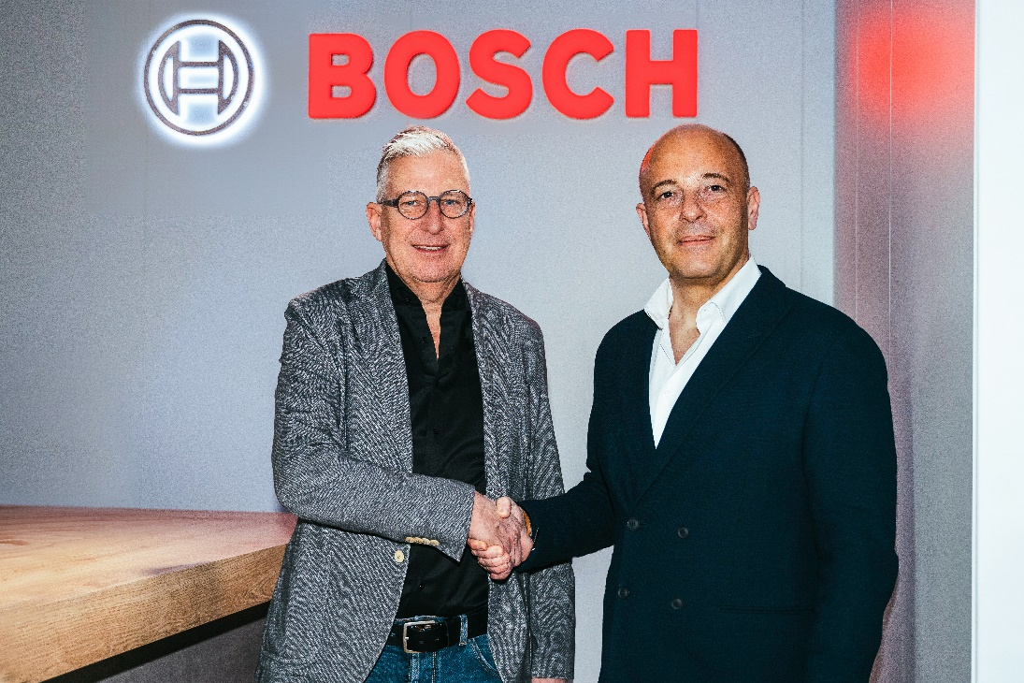

Agreed to project-based collaboration: Dr. Johannes-Jörg Rüger, president Bosch Engineering GmbH and Cosimo De Carlo, CEO EDAG Group

Contact persons for press inquiries:
Cornelia Dürr Felix Schuster
Email: Cornelia.Duerr@de.bosch.com Email: felix.schuster@edag.com
Phone: +49 7062 911-1986 Phone: +49 173 7345473

About the EDAG Group
The EDAG Group is a globally leading, independent engineering services provider that combines excellent engineering with the latest technology trends.

With a global network of some 60 branches, the EDAG Group realizes projects in the Vehicle Engineering, Electrics/Electronics and Production Solutions segments. Drawing on more than 50 years of engineering experience, EDAG's proprietary 360-degree development approach has become a hallmark of quality in the holistic development of vehicles and smart factories. The company's interdisciplinary expertise in the areas of software and digitization provides it with crucial skills to actively shape dynamic transformation processes as an innovative partner.

With an interdisciplinary team of around 8,600 experts, the EDAG Group develops unique mobility and industrial solutions for customers that include the world's leading automotive and non-automotive companies. The company is listed on the stock exchange since 2015 and generated revenues of € 796 million in 2022.

For more information, see the EDAG Group website: www.edag.com

Do you have any questions, or need further information?
I look forward to hearing from you:
Felix Schuster Head Office
Head of Marketing & Communications EDAG Engineering GmbH
Cell phone: +49 173 7345473 Kreuzberger Ring 40
Email: felix.schuster@edag.com 65205 Wiesbaden
www.edag.com

About Bosch Engineering GmbH

Bosch Engineering GmbH is a wholly owned subsidiary of Robert Bosch GmbH and is head-quartered in Abstatt, Germany. As a systems development partner to the automotive industry since 1999, the company with its more than 3,300 associates offers development services for powertrains, safety and convenience systems, and electrical and electronic systems – from the original concept to series production. Specialized in electronics and software, it draws on Bosch’s proven large-scale series production technology to develop tailored solutions for a wide variety of applications in passenger cars, commercial vehicles, off-highway and recreational vehicles, and in rail applications, ships, and industry. Bosch Engineering GmbH also coordinates all the Bosch Group’s motorsports activities.

Additional information can be accessed at www.bosch-engineering.com.

Mobility is the largest Bosch Group business sector. According to preliminary figures, it generated sales of 56.3 billion euros in 2023, and thus contributed almost 60 percent of total sales. This makes the Bosch Group one of the leading automotive suppliers. The Mobility business sector pursues a vision of mobility that is safe, sustainable, and exciting. For its customers, the outcome is integrated mobility solutions. The business sector’s main areas of activity are injection technology and powertrain peripherals for internal-combustion engines, diverse solutions for powertrain electrification, vehicle safety systems, driver-assistance and automated functions, technology for user-friendly infotainment as well as vehicle-to-vehicle and vehicle-to-infrastructure communication, repair-shop concepts, and technology and services for the automotive aftermarket. Bosch is synonymous with important automotive innovations, such as electronic engine management, the ESP anti-skid system, and common-rail diesel technology.

The Bosch Group is a leading global supplier of technology and services. It employs roughly 428,000 associates worldwide (as of December 31, 2023). According to preliminary figures, the company generated sales of 91.6 billion euros in 2023. Its operations are divided into four business sectors: Mobility, Industrial Technology, Consumer Goods, and Energy and Building Technology. As a leading IoT provider, Bosch offers innovative solutions for smart homes, Industry 4.0, and connected mobility. Bosch is pursuing a vision of mobility that is sustainable, safe, and exciting. It uses its expertise in sensor technology, software, and services, as well as its own IoT cloud, to offer its customers connected, cross-domain solutions from a single source. The Bosch Group’s strategic objective is to facilitate connected living with products and solutions that either contain artificial intelligence (AI) or have been developed or manufactured with its help. Bosch improves quality of life worldwide with products and services that are innovative and spark enthusiasm. In short, Bosch creates technology that is “Invented for life.” The Bosch Group comprises Robert Bosch GmbH and its roughly 470 subsidiary and regional companies in over 60 countries. Including sales and service partners, Bosch’s global manufacturing, engineering, and sales network covers nearly every country in the world. The basis for the company’s future growth is its innovative strength. At 136 locations across the globe, Bosch employs some 90,000 associates in research and development, of which roughly 48,000 are software engineers.

Additional information is available online at www.bosch.com, www.iot.bosch.com, www.bosch-press.com.

