Press Announcement

Electric roofing: EDAG Czech Republic and ALBIXON win Red Dot Award for swimming pool cover moving system

Fulda, June 20, 2023 - The EDAG Group, development service provider for complex engineering solutions in the mobility industry, has won the "Red Dot Award" design prize with its Czech subsidiary. The award was bestowed for the 'MOOVER' pool cover moving system developed with partner ALBIXON. On behalf of the Czech swimming pool manufacturer, the company applied a holistic approach to develop an electric swimming pool cover moving system: the order included complete product development from the initial idea all the way to series production.
A comfortable and user-friendly design
Thanks to its unique design, MOOVER can be installed in the most pool enclosures. The integrated solar panels ensure that the cover is easily opened and closed throughout the season. However, at times when there is little sunlight, MOOVER can also simply be connected to the mains and recharged. A digital LED panel indicates the current battery level and movement orientation. The overall design of the pool enclosure is minimalist and elegant. The jury was impressed by "the user-friendliness of a product solution that uses solar energy to provide a powerful user experience suitable for everyday use".
MOOVER can be easily installed by the end customer. The practical and environmentally friendly packaging even helps with assembly. And its use is also extremely simple: the cover can be conveniently remote controlled from a range of up to 15 meters. Up to ten of these remote controls can be paired with one unit at the same time.
"We are extremely proud of this innovative and challenging project," says Aleš Paldus, Managing Director EDAG Engineering CZ. "Thanks to our great team and the constructive cooperation with ALBIXON, we were able to implement MOOVER to offer the greatest benefit - true to the 'Motion is life!' motto. We are very pleased that our joint development has been honoured by the renowned jury of the Red Dot Award and would like to thank everyone involved for their great cooperation throughout the project. This encompassed all process steps from the idea to certification." After a joint definition of the main functions of the cover and the client's expectations, the EDAG Group team focused on intensive research and analysis, the results of which formed the basis of the conceptual phase. Design drawings and user studies formed the basis for the mechanical and electrical engineering. Once several prototypes had been constructed, it was possible to submit the first electric pool cover to long-term testing. For the final product - MOOVER - the EDAG team developed sustainable packaging and an appropriate, timeless graphic design. In addition, the engineering service providers managed the certification process.
The Red Dot Design Award is an annual competition Design competition for Product and industry design, brand and communication design as well as design concepts, in which the Red Dot is awarded as a quality label.
Further information on the MOOVER can be found here: https://www.moover.eu/

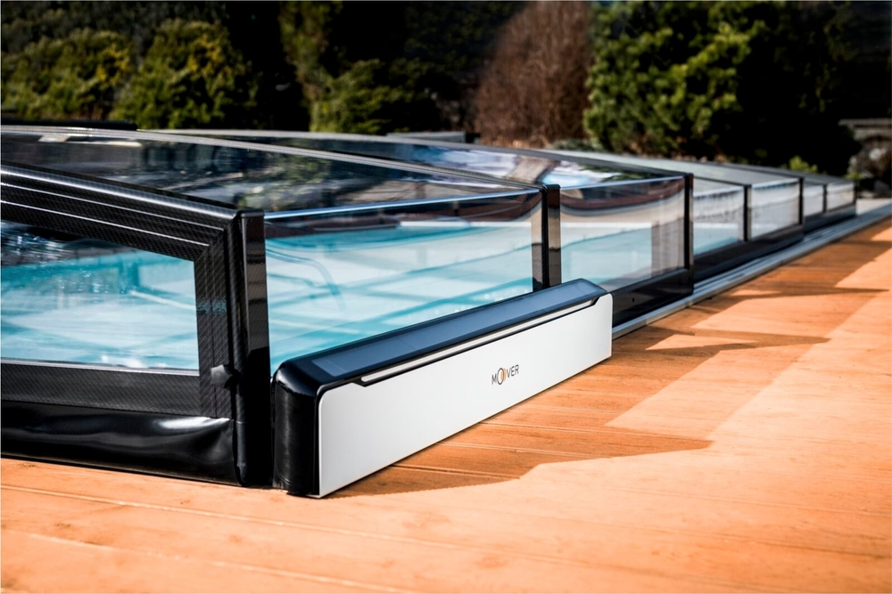

Red Dot DESIGN Award-winning MOOVER, a pool cover moving system (photo: EDAG Group)

About EDAG
EDAG is the world's largest independent engineering service provider to the global mobility industry.
We regard mobility as a fully integrated ecosystem, and offer our customers technological solutions for more sustainable, emission-free and intelligently networked mobility.
With a global network of some 60 branches, EDAG provides engineering services in the Vehicle Engineering, Electrics/Electronics and Production Solutions segments.
With our interdisciplinary expertise in the fields of software and digitalization, we possess the key skills to help actively shape the dynamic transformation process the mobility industry is currently undergoing. Digital features, autonomous driving, artificial intelligence, alternative powertrains, new mobility concepts and the vision of a networked smart city have become an integral part of our portfolio. Embedded in EDAG's own 360 degree approach to the development of complete vehicles and production facilities, we are a competent partner for sustainable mobility projects. It is in the DNA of the company to actively shape the future of mobility and transfer new technologies and concepts into series production. Today, EDAG is one of the TOP 20 IT service providers in the German mobility sector.
Our customers include leading international OEMs, tier 1 suppliers and startup companies from the automotive and non-automotive industries, all of whom we serve globally with our workforce of approximately 8,400 experts in 360-degree engineering.
In 2022, the company generated sales of € 796 million. On December 31, 2022, EDAG employed a global workforce of 8,412 (including apprentices).

Do you have any questions, or need further information?
I look forward to hearing from you:
Felix Schuster Head Office
Head of Marketing & Communications EDAG Engineering GmbH
Cell phone: +49 173 7345473 Kreuzberger Ring 40
Email: felix.schuster@edag.com 65205 Wiesbaden
www.edag.com

