Press Announcement

Flying High: EDAG aeromotive GmbH celebrates tenth anniversary as a result of reliable expertise and innovative projects

Ingolstadt, 8/3/2023 - As EDAG aeromotive GmbH celebrates its tenth anniversary, it looks back on a great many successfully completed projects for the aerospace industry. This long-standing expertise means that the aeromotive specialists are always familiar with the latest developments in the sector. As part of the EDAG Group, the world's largest independent engineering service provider in the vehicle and production plant development sectors, the company can use synergies promising substantial benefits to the customer: The transfer of innovative automotive technologies to the aviation industry helps to meet the high quality requirements for developments in the aerospace industry.

One example of how future-oriented methods can be linked across different industries is model-based testing (MBT). This means the use of models for the automated generation of test cases and test case descriptions. The system independently evaluates possible test scenarios - depending on the previously defined factors. The simplified manageability in the generation of the test cases makes the the test process more cost-effective and the test quality less dependent on specific individuals. One thing that all model-based testing methods have in common is the derivation of test cases from a graphical presentation of the test idea: the test model. The representations of the scenarios being tested are entirely in graphical form – in an activity diagram using UML (Unified Modeling Language). From this, the system generates executable test cases, in this way representing an additional element for a fully automated test process.

"The aviation industry is a pioneer, and often the first to use innovative technologies," explains Ralf Rudolf, CEO of EDAG aeromotive GmbH. "Due to the great complexity of the end product, however, the development cycles are longer than they are in the automotive industry. Automated software testing now makes a significant contribution to increasing efficiency, as capacities are freed up and the pace of development is increased. EDAG aeromotive GmbH takes on various tasks in this process, including the creation and maintenance of complete test procedures (including test documentation), but also the performance of manual, semi-automated and fully automated test procedures. This expertise in the field of test automation is also integrated into the maintenance and modernization of scripted and GUI-based test procedures. By means of efficient regression testing and extensive bug tracking and reporting, EDAG aeromotive GmbH supports its customers in assuring the quality of the software tool.

What once began as a small division is now a separate company with almost 50 employees: EDAG aeromotive GmbH, an EDAG Group subsidiary, has been developing engineering solutions for the fields of aerospace and defense for a decade now. The Gaimersheim-based company's success story began in 2011: Originally a department for aerospace technology under the umbrella of the former BFFT Gesellschaft für Fahrzeugtechnik mbH, a handful of experts began working in this segment with the aim of taking innovative vehicle technologies and transferring them to the aerospace industry. Due to the fact that they possessed the ability to meet the high quality standards in aerospace engineering from the very outset, the department recorded steady growth until, in 2013, an independent company – BFFT aeromotive GmbH – was founded. In 2013, the company's founding year, it was named a StratX 2020 Supplier by customer and partner Airbus Defence & Space. This trust is the basis of the company's positive development.

Since 2014, BFFT aeromotive GmbH has been part of the EDAG Group. The change of name reinforces the fact that EDAG aeromotive GmbH belongs to the EDAG Group. Since March 2020, the Competence Center for Aerospace und Defense Technology at EDAG Engineering GmbH has been operating under the name EDAG aeromotive. As an integral part of the world's largest independent engineering service provider in vehicle and production plant development, EDAG aeromotive GmbH, along with its customers and partners, now has access to EDAG's global network. As long-standing experts in the field of aerospace & defense technology, EDAG aeromotive GmbH is always at the cutting edge of the latest developments in the industry. Our experts recognize new trends in software and hardware development in the aviation industry at an early stage, and, by quickly analyzing current market developments and developing market-ready solutions, transform the resulting opportunities into competitive advantages for our customers. EDAG aeromotive GmbH also supports its customers in the production, validation and development of system environments for testing, analysis and evaluation applications.

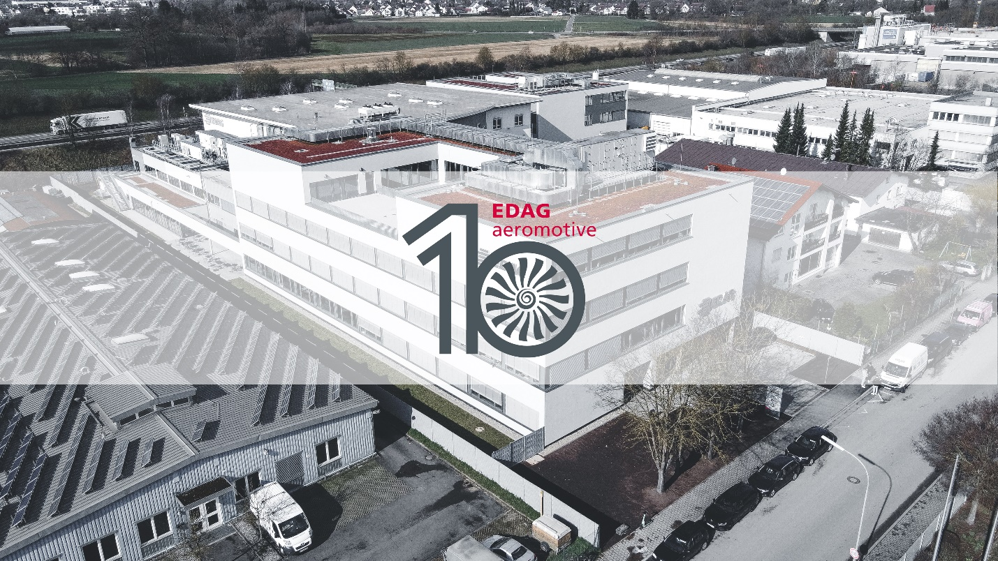
Celebrates its tenth anniversary: EDAG aeromotive GmbH (Photo: EDAG Group)
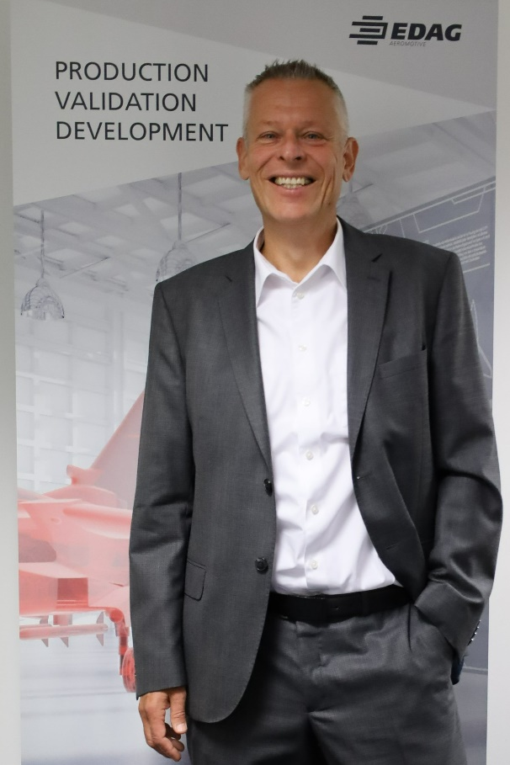

Ralf Rudolf, CEO of EDAG aeromotive GmbH (Photo: EDAG Group)

About EDAG
EDAG is the world's largest independent engineering service provider to the global mobility industry.
We regard mobility as a fully integrated ecosystem, and offer our customers technological solutions for more sustainable, emission-free and intelligently networked mobility.
With a global network of some 60 branches, EDAG provides engineering services in the Vehicle Engineering, Electrics/Electronics and Production Solutions segments.
With our interdisciplinary expertise in the fields of software and digitalization, we possess the key skills to help actively shape the dynamic transformation process the mobility industry is currently undergoing. Digital features, autonomous driving, artificial intelligence, alternative powertrains, new mobility concepts and the vision of a networked smart city have become an integral part of our portfolio. Embedded in EDAG's own 360 degree approach to the development of complete vehicles and production facilities, we are a competent partner for sustainable mobility projects. It is in the DNA of the company to actively shape the future of mobility and transfer new technologies and concepts into series production. Today, EDAG is one of the TOP 20 IT service providers in the German mobility sector.
Our customers include leading international OEMs, tier 1 suppliers and startup companies from the automotive and non-automotive industries, all of whom we serve globally with our workforce of approximately 8,400 experts in 360-degree engineering.
In 2022, the company generated sales of € 796 million. On December 31, 2022, EDAG employed a global workforce of 8,412 (including apprentices).

Do you have any questions, or need further information?
I look forward to hearing from you:

Felix Schuster Head Office
Head of Marketing & Communications EDAG Engineering GmbH
Cell phone: +49 173 7345473 Kreuzberger Ring 40
Email: felix.schuster@edag.com 65205 Wiesbaden
www.edag.com

